REBOUND

A PROJECT REPORT

Submitted by

AKSHITA SHARMA [RA2211026010268]
ANSHITA SRIVASTAVA [RA2211026010278]

Under the Guidance of

DR. R. SIVA

(Associate Professor, Department of Computational Intelligence)

in partial fulfillment of the requirements for the degree of

BACHELOR OF TECHNOLOGY

in

COMPUTER SCIENCE ENGINEERING

with specialization in Artificial Intelligence and Machine Learning


DEPARTMENT OF COMPUTATIONAL INTELLIGENCE

COLLEGE OF ENGINEERING AND TECHNOLOGY
SRM INSTITUTE OF SCIENCE AND TECHNOLOGY

KATTANKULATHUR- 603 203

MAY 2026


Department of Computational Intelligence

SRM Institute of Science & Technology

Own Work Declaration Form

This sheet must be filled in (each box ticked to show that the condition has been met). It must be signed and dated along with your student registration number and included with all assignments you submit – work will not be marked unless this is done.
To be completed by the student for all assessments

Degree/ Course : BTech in Computer Science Engineering with Specialization in Artificial Intelligence and Machine Learning

Student Name : Akshita Sharma, Anshita Srivastava

Registration Number :RA2211026010268, RA2211026010278

Title of Work : Rebound
We hereby certify that this assessment compiles with the University’s Rules and Regulations relating to academic misconduct and plagiarism, as listed in the University Website, Regulations, and the Education Committee guidelines.

We confirm that all the work contained in this assessment is our own except where indicated, and that We have met the following conditions:

- Clearly referenced / listed all sources as appropriate
- Referenced and put in inverted commas all quoted text (from books, web, etc)
- Given the sources of all pictures, data etc. that are not my own
- Not made any use of the report(s) or essay(s) of any other student(s) either past or present
- Acknowledged in appropriate places any help that I have received from others (e.g. fellow students, technicians, statisticians, external sources)
- Compiled with any other plagiarism criteria specified in the Course handbook / University website
We understand that any false claim for this work will be penalized in accordance with the University policies and regulations.

DECLARATION:
I am aware of and understand the University’s policy on Academic misconduct and plagiarism and I certify that this assessment is our own work, except where indicated by referring, and that I have followed the good academic practices noted above.

Akshita Sharma [RA2211026010268] Anshita Srivastava [RA2211026010278]

SRM INSTITUTE OF SCIENCE AND TECHNOLOGY KATTANKULATHUR – 603 203

BONAFIDE CERTIFICATE

Certified that 21CSP401L/21CSP402L – Major Project [21CSP403L- Internship] report titled “REBOUND” is the bonafide work of “AKSHITA SHARMA[RA2211026010268], ANSHITA SRIVASTAVA[RA2211026010278]” who carried out the project work under my supervision. Certified further, that to the best of my knowledge the work reported herein does not form any other project report or dissertation on the basis of which a degree or award was conferred on an earlier occasion on this or any other candidate.

SIGNATURE SIGNATURE

DR. R. SIVA DR. R. ANNIE UTHRA
SUPERVISOR  ASSOCIATE PROFESSOR  DEPARTMENT OF COMPUTATIONAL INTELLIGENCE |  | HEAD OF DEPARTMENT  DEPARTMENT OF COMPUTATIONAL INTELLIGENCE
EXAMINER 1 EXAMINER 2

ACKNOWLEDGEMENTS

We express our humble gratitude to Dr. C. Muthamizhchelvan, Vice-Chancellor, SRM Institute of Science and Technology, for the facilities extended for the project work and his continued support.

We extend our sincere thanks to Dr. Leenus Jesu Martin M, Dean-CET, SRM Institute of Science and Technology, for his invaluable support.

We wish to thank Dr. Revathi Venkataraman, Professor and Chairperson, School of Computing, SRM Institute of Science and Technology, for her support throughout the project work.

We encompass our sincere thanks to, Dr. M. Pushpalatha, Professor and Associate Chairperson - CS, School of Computing and Dr. C Lakshmi, Professor and Associate Chairperson -AI, School of Computing, SRM Institute of Science and Technology, for their invaluable support.

We are incredibly grateful to our Head of the Department, Dr. R. Annie Uthra, Department of Computational Intelligence, SRM Institute of Science and Technology, for her suggestions and encouragement at all the stages of the project work.

We want to convey our thanks to our Project Coordinators, Panel Head, and Panel Members Department of Computational Intelligence, SRM Institute of Science and Technology, for their inputs during the project reviews and support.

We register our immeasurable thanks to our Faculty Advisor Dr. Nagendra Prabhu S, Department of Computational Intelligence, SRM Institute of Science and Technology, for leading and helping us to complete our course.

Our inexpressible respect and thanks to our guide, Dr. R. Siva Department of Computational Intelligence, SRM Institute of Science and Technology, for providing us with an opportunity to pursue our project under his mentorship. He provided us with the freedom and support to explore the research topics of our interest. His passion for solving problems and making a difference in the world has always been inspiring.

We sincerely thank all the staff members of Department of Computational Intelligence, School of Computing, S.R.M Institute of Science and Technology, for their help during our project. Finally, we would like to thank our parents, family members, and friends for their unconditional love, constant support and encouragement

Authors

ABSTRACT

In the analysis of systematic performance in sports, there should be an organized and manageable record of performance data. Unfortunately, amateur players lack an effective method for recording their statistics in games. As a result, there is no proper documentation of their performance. The study aims at developing an efficient game logging system. The system is intended to offer a unified platform that can be used in documenting game events, recording statistics, and retrieving analysis based on aggregated data. The system is based on a mobile platform that ensures performance tracking is consistent. The study’s findings highlight the need for centralized game logging in performance documentation and analysis. By integrating a mobile interface with a cloud-based data infrastructure, the platform supports consistent performance tracking and improved accessibility of sports data. The results demonstrate the centralized game logging can enhance performance documentation and provide meaningful analytical insights for athletes and coaches.

TABLE OF CONTENTS
ABSTRACT v

TABLE OF CONTENTS vi

LIST OF FIGURES vii

LIST OF TABLES viii

ABBREVIATIONS ix

CHAPTER TITLE PAGE
NO. NO.

1 INTRODUCTION 1
  - Introduction to Project 1
  - Problem Statement 1
  - Motivation 2
  - Sustainable Development Goal of the Project 3
2 LITERATURE SURVEY 4
2.1 Overview of the Research Area 4
2.2 Existing Models and Frameworks 4
2.3 Limitations Identified from Literature Survey (Research Gaps) 5
2.4 Research Objectives 5
2.5 Product Backlog (Key user stories with Desired outcomes) 6
2.5 Plan of Action (Project Road Map) 6

3 SPRINT PLANNING AND EXECTION METHODOLOGY 8
3.1 SPRINT I User Onboarding and Team Establishment 8
3.1.1 Objectives with user stories of Sprint I 8
3.1.2 Functional Document 8
3.1.3 Architecture Document 10
3.1.4 Outcome of objectives/ Result Analysis 11
3.1.5 Sprint Retrospective 12 3.2 SPRINT II Game Logging and Performance Analytics 13
3.2.1 Objectives with user stories of Sprint II 13
3.2.2 Functional Document 14
3.2.3 Architecture Document 16
3.2.4 Outcome of objectives/ Result Analysis 17
3.2.5 Sprint Retrospective 19

3.3 SPRINT III Administrative Control and System Refinement 20
3.3.1 Objectives with user stories of Sprint III 20
3.3.2 Functional Document 20
3.3.3 Architecture Document 22
3.3.4 Outcome of objectives/ Result Analysis 23
3.3.5 Sprint Retrospective 25
4 RESULTS AND DISCUSSIONS 27
4.1 Performance Evaluation
4.2 Visualization and Comparison
4.3 Visualization and Analysis
4.4 Discussion of Results

5 CONCLUSION AND FUTURE ENHANCEMENT 31
REFERENCES 32
APPENDIX
A CODING 33
B CONFERENCE PUBLICATION 38
C JOURNAL PUBLICATION 40
D PLAGIARISM REPORT 41

LIST OF FIGURES

CHAPTER TITLE PAGE
NO. NO.

1 | Athlete Management Workflow | 7
2 | Team-Level Analysis | 10
3 | Athlete Home Screen | 12
4 | Athlete Profile Screen | 12
5  6  7  8  9  10  11  12  13  14  15  16  17  18  19  20  21  22 | Coach Home Screen  Create Team Screen  Performance Analysis System  Create Game Screen  Log Entering Screen  Coach List of Approval Requests  Score Approval Screen-1  Score Approval Screen-2  Match History List  Match Stats  Admin Home Screen  Database Schema  Player Analytics Screen  Graphs Showing Progress  In-Depth Progress  Team Details Screen  Trends and KPIs Screen  In-depth Analysis | 12  12  15  18  18  18  18  18  19  19  24  25  29  29  29  30  30  30

vii

LIST OF TABLES

CHAPTER TITLE PAGE
1 | Advantages of Proposed System | 2
2 | Detailed User Stories | 6
3 | Detailed User Stories of Sprint 1 | 8
4 | Detailed User Stories of Sprint 2 | 13
5 | Detailed User Stories of Sprint 3 | 20
6 | System Modules Overview | 23
7 | Sprint-wise Development Progress and Completion Status | 26
8 | Module-wise Functional Testing Results and Success Rate | 26
9 | Testing and Feedback Summary | 28
NO. NO.

viii

ABBREVIATIONS

• 2P: Two Points Scored
• 3P: Three Points Scored
• STL: Steals
• PTS: Points
• Position Abbreviations:
o PG: Point Guard
o SG: Shooting Guard
o SF: Small Forward
o PF: Power Forward
o C: Center
o G: Guard
o F: Forward
• PPG: Points per Game
• RPG: Rebounds per Game
• AST: Assists • PFG: Point Field Goals
• FT: Free Throw(s)

ix
CHAPTER 1

INTRODUCTION

  - Introduction to Rebound
In the world of sports, consistent performance tracking and documentation are essential for growth, recognition, and opportunityThe main issue is that most of the available tools are designed mainly for professionals or teams that are popular enough, and there is a large need for something to help young athletes and regional teams track their progress. Rebound is an online application created for athletes and coaches to have a place where they can document and analyse their gameplay. Whether it's logging the results of a local basketball match, tracking individual player statistics like assists and rebounds, or sharing milestones through posts, Rebound ensures that every athlete—regardless of level—has access to professional-grade tools for their development.
The Rebound project comes with functionalities including the creation of games and teams, game logs through statistics, timeline representations, and the search for athletes/coaches profiles. With the ability to combine statistical information with social media and portfolio development capabilities, Rebound not only helps athletes improve their performance but also allows them to display their improvements and seek out sponsorships, team selection opportunities, and scouting services. In effect, Rebound is more than just a tool for collecting statistics; it is a virtual partner for athletes and coaches seeking to own the process of developing their sport.
Problem Statement
It is important to note that in today's sports world, the process of documenting performance, its analysis and even showing the results is not an easy one for amateur athletes and local teams. Professional athletes have more sophisticated solutions to their problems such as analysis and statistics software, scouting sites, media representation etc. In contrast, amateur athletes usually keep information about their achievements using memory, notes, spreadsheets and any other similar ways. As a result, it becomes hard to trace the dynamics of their performance and find weak sides of training to develop further skills, create a portfolio and gain attention of their potential coaches, scouts, sponsors, or recruiters.
The problem of monitoring performance of amateur athletes and teams' management is faced by coaches and team managers as well. Sports-related websites usually provide professional league information and some services for elite athletes, but not amateur players, schools' teams, college students or independent clubs. Moreover, no platforms exist where different functions such as statistics analysis, portfolio creation, team management, and social sharing would be interconnected. Rebound provides a solution to this problem creating innovative product that will make life easier for both athletes and their mentors.
Table 1: Advantages of Proposed System
Feature | Description | Benefit
Centralized Data | Stores all athlete data in one place | Easy access and management
Performance Tracking | Tracks player statistics | Better decision-making
Analytics Dashboard | Visual representation of data | Improved insights
Real-time Updates | Updates match data instantly | Accurate information
User-Friendly Interface | Simple UI for users | Easy usability

  - Motivation
The idea behind Rebound was born from a real and recurring challenge faced by local athletes and coaches—there is no accessible, organized way to track and analyze athletic performance at the grassroots or amateur level. While professional athletes benefit from advanced analytics, scouting platforms, and media exposure, aspiring players often rely on memory, scattered notes, or informal word-of-mouth to document their achievements and growth. This lack of structure not only hinders self-improvement but also creates barriers when athletes seek recognition, sponsorships, or career advancement. Coaches, too, struggle to evaluate performance trends over time without consistent records. Motivated by this gap, Rebound seeks to democratize access to performance tracking tools by offering an intuitive, affordable, and centralized mobile platform. The goal is to empower every athlete—from school-level players to independent club members—with the ability to log games, visualize progress, share accomplishments, and build a credible sports portfolio.
The project is driven by a passion to bridge the inequality in sports analytics and provide every athlete with the tools they need to grow, be discovered, and reach their full potential.
  - Sustainable Development Goal of the Project
Rebound fits within the scope of Sustainable Development Goal 9 proposed by the UN, which centers on developing infrastructure, promoting sustainable industrialization, and encouraging innovation. Rebound plays its part in helping the organization reach its goal through the integration of digital innovation in the grassroots athletics community, an industry segment that is frequently ignored when developing technological products. With the help of modern-day mobile technologies and data analysis methods, Rebound develops a highly scalable digital infrastructure that helps athletes and coaches keep track of their sports performance and improve it using the information obtained via the platform's analytics capabilities. Rebound promotes innovation by bringing a new perspective to the process of monitoring the achievements of an athlete and providing coaches with the necessary data in an innovative way. By allowing athletes to record their progress in the sport through visual and digital means, the platform encourages innovation and brings a positive change in the industry.
CHAPTER 2

LITERATURE SURVEY

  - Overview of the Research Area
The integration of digital technologies in sports has transformed how performance is analysed, recorded, and utilized for decision-making. Performance analytics systems in sports aim at gathering, storing, and analyzing information associated with player movement, game statistics, and team performance. These tools assist athletes and coaches in monitoring their development, determining strengths and weaknesses, and improving performance through data analysis.
Despite the development of technologies in the field of sports, most innovations target professionals and necessitate the use of advanced infrastructure. At the amateur and semi-professional levels, athletes often rely on informal methods such as manual record-keeping or basic applications that lack structure and reliability. There is an increasing demand for systems that will help in structured management of data, monitoring performance, and verification while at the same time being easily usable.
The field, thus, addresses the creation of scalable and user-friendly systems that integrate performance measurement and management, analytics, and team management along with social collaboration in a single digital platform.
2.2 Existing Models and Frameworks
Various systems and platforms exist that partially address sports performance tracking and athlete management:
- Professional Sports Analytics Systems
These platforms provide advanced analytics, real-time data processing, and detailed performance insights.
- Fitness Tracking Applications
General-purpose applications allow users to monitor health metrics and physical activities. While useful for individual tracking, they do not support structured match data, team workflows, or sport-specific analytics.
- Team and Club Management Platforms
Such solutions are mainly concerned with the coordination of teams, scheduling, and communication. Nonetheless, they miss features such as performance tracking, verification, and analysis.
- Standalone Game Logging Tools
This refers to solutions that allow users to input game information. They do not have verification methods and analytics built into them.
- Social Media Platforms
It is common for athletes to post their accomplishments on social media sites. Nevertheless, there are no performance records on these sites.
In summary, current platforms offer solutions to various problems in sports management; however, they fail to provide a comprehensive approach.
2.3 Limitations Identified from Literature Survey (Research Gaps)
Based on the study of existing systems and practical workflows, the following research gaps are identified:
- Absence of centralized platforms combining performance tracking, validation, and showcasing
- Lack of role-based workflows (athlete, coach, admin) for managing and approving data
- No verification mechanism for ensuring authenticity of match statistics
- Limited support for team-based collaboration and management
- Inadequate performance visualization tools such as timelines and dashboards
- Lack of structured onboarding and profile management systems
- Absence of approval systems (e.g., coach approval for game logs, admin approval for coaches)
- Poor integration between analytics and social sharing features
- Existing systems are either too complex or too basic, with no balanced solution
These limitations highlight the need for a comprehensive system that integrates all functionalities into a single platform.
2.4 Research Objectives
The key objectives include:
- To develop a secure user registration and authentication system
- To enable profile creation and management for athletes and coaches
- To design a team management system supporting team creation and joining workflows
- To implement a game logging system for recording match statistics
- To introduce a verification workflow where coaches approve game logs
- To incorporate admin-level approval mechanisms for coach validation
- To provide performance analytics and visualization tools such as dashboards and timelines
- To enable search and discovery features for athletes, coaches, and teams
- To integrate social sharing functionality for showcasing achievements
- To ensure the system is scalable, user-friendly, and reliable
  - Product Backlog (Key user stories with Desired outcomes)
Table 2: Detailed User Stories
User Story ID | User Story | Desired Outcome
US1 | As a user, I want to register on the platform | Secure account creation and access
US2 | As an athlete, I want to create and manage my profile | Display personal and professional details
US3 | As an athlete, I want to join a team | Connect with teams and participate in matches
US4 | As a user, I want to log game performance | Record structured match data
US5 | As a coach, I want to approve game logs | Ensure data authenticity and reliability
US6 | As an athlete, I want to view a timeline of games | Track performance chronologically
US7 | As a user, I want to view performance analytics | Analyze trends and improvements
US8 | As a user, I want to create a team | Manage team structure and players
US9 | As an athlete, I want to share game logs | Showcase achievements publicly
US10 | As a user, I want to search for athletes and teams | Enable networking and discovery
US11 | As an athlete, I want a dashboard | View summarized performance insights
US12 | As a coach, I want admin approval | Ensure only verified coaches access features
US13 | As an admin, I want to approve/reject coaches | Maintain system authenticity and control
2.6 Plan of Action (Project Road Map)
The development of Rebound follows a structured and iterative approach:
Phase 1: Requirement Analysis
- Understanding user roles (athletes, coaches, admin)
- Defining system features and workflows
- Preparing functional documentation and test cases
Phase 2: System Design
- Designing architecture and database schema
- Creating UI/UX designs for onboarding, dashboards, and analytics
- Defining role-based access control mechanisms
Phase 3: Development
- Implementing user registration and authentication
- Developing profile and team management modules
- Building game logging and approval workflows
- Integrating search and social features
Phase 4: Testing
- Executing functional test cases for all features
- Validating workflows such as registration, approvals, and logging
- Ensuring accuracy of analytics and data visualization
Phase 5: Deployment
- Deploying the application
- Ensuring performance, scalability, and security
Phase 6: Future Enhancements
- AI-based performance insights
- Expansion beyond basketball to multiple sports
- Advanced analytics and recommendation systems
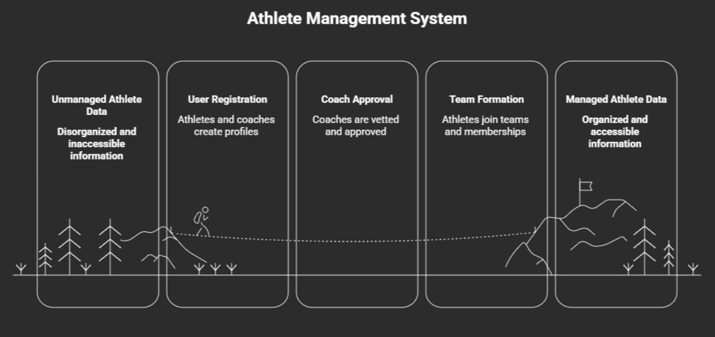
Fig 1. Athlete Management Workflow

CHAPTER 3

SPRINT PLANNING AND EXECTION METHODOLOGY

3.1.1 Objectives with User Stories of Sprint I
Sprint I was primarily focused on building the foundational modules required for enabling user entry into the Rebound platform and establishing the initial sports network environment. The goal of this sprint was to allow new users to be able to register, set up their sports profile, form their teams, and also become members of an already formed team. This sprint served as the groundwork upon which all subsequent game tracking and analytics functionalities would operate.
The major objectives defined for Sprint I are as follows:
- To design and implement a secure user registration mechanism for athlete and coach roles.
- To validate uniqueness of user credentials during registration.
- To enable athletes to complete their sports-specific profile information.
- To provide users with the ability to create a new team.
- To allow athletes to search and request joining of an existing team.
- To establish database relations among users, profiles, and teams for future game log integration.
The following user stories were selected and completed during Sprint I:
Table 3: Detailed User Stories of Sprint 1
User Story ID | User Story Description
US1 | As a new user, I want to register into the application using my credentials so that I can access Rebound services.
US2 | As an athlete, I want to set up my sports profile by entering personal and athletic details so that my profile reflects my playing identity.
US3 | As an athlete, I would like to be able to join a pre-existing team for team activity participation.
US4 | As a user, I would like to be able to create a team for myself for sports event management/participation.
These user stories were prioritized in Sprint I because they establish the minimum working ecosystem required before implementing match management, analytics, and administrative control in future sprints.

3.1.2 Functional Document
Sprint I consisted of implementing the core front-end and back-end functionalities associated with user onboarding and team establishment. Each functionality was developed, integrated with the Supabase backend, and validated through functional testing.
A. User Registration Module
This feature provides the capability for new users to sign up for an account, where they have to provide their credentials including name, email, password, and choice of roles. After validating that the email provided is not in use by anyone else, an account is created for the new user.
Inputs:
- Full Name
- Email Address
- Password
- User Role (Athlete/Coach)
Outputs:
- Successful account creation
- Error prompt for duplicate email

B. Athlete Profile Setup Module
After registration, athlete users are prompted to complete their sports profile by entering domain-specific attributes. These details help personalize the athlete profile and become useful for future analytics generation.
Inputs:
- Height
- Weight
- Playing Position
- Experience Level
Outputs:
- Athlete profile stored in database
- Profile visible in athlete dashboard

C. Team Creation Module
This functionality enables a registered athlete or coach to create a new team by specifying team details. The creator is automatically assigned ownership privileges for that team.
Inputs:
- Team Name
- Team Description / Sport Category
Outputs:
- New team created successfully
- Creator linked as team owner

D. Join Existing Team Module
Athletes can search for teams present in the application and send a request to join. The request is stored for future validation and participation under the selected team.
Inputs:
- Search Team Name
- Send Join Request
Outputs:
- Join request successfully submitted
- Athlete linked to pending team membership
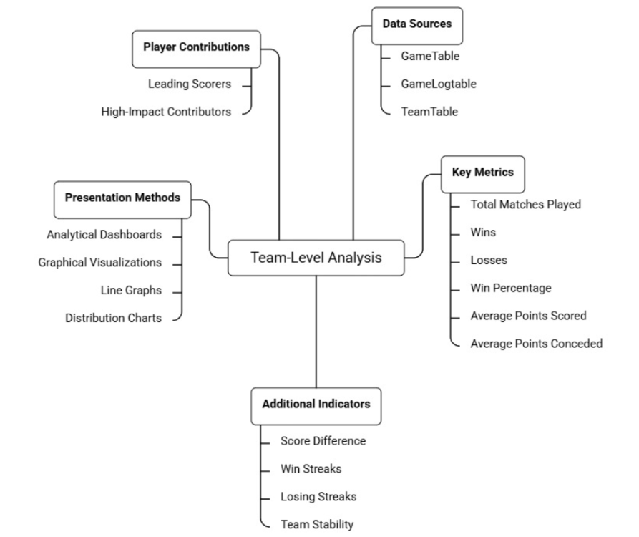
Fig 2. Team-Level Analysis

3.1.3 Architecture Document
Sprint I required the implementation of a foundational database architecture connecting user identity, athlete profile information, and team management.
This database architecture built in Sprint I used the client-server approach, whereby the flutter-based frontend interacted with the backend services provided by Supabase.
Components Developed in Sprint I
1. Authentication Layer
Responsible for:
- user sign-up,
- credential validation,
- duplicate email verification,
- role assignment.
Authentication is carried out using the Supabase Authentication API.

2. Profile Management Layer
Responsible for:
- capturing athlete-specific details,
- storing player metadata,
- linking athlete profile to the registered user.
This information is maintained in the AthleteTable.

3. Team Management Layer
Responsible for:
- creating team records,
- maintaining team ownership,
- handling join requests,
- mapping users to teams.
Primary database tables used:
- TeamTable
- TeamMemberTable

4. Frontend Interface Layer
flutter views developed:
- Registration Screen
- Athlete Profile Setup Screen
- Create Team Screen
- Join Team Search Screen
These views interact with backend ViewModels for data transmission.

3.1.4 Outcome of Objectives / Result Analysis
At the end of Sprint I, all planned onboarding and team establishment objectives were successfully achieved. The functionality test results revealed that there were no problems in the registration process, storage of athletes' information, formation of new teams, and the ability of the athletes to request membership in existing teams.
The major outcomes obtained from this sprint are listed below:
- Successful implementation of secure user registration with duplicate email detection.
- Correct role-based creation of athlete and coach accounts.
- Complete athlete profile setup functionality with database persistence.
- Successful creation of athlete profiles and saving in the database.
- Smooth join request workflow for athletes joining an existing team.
- Successful establishment of relationships between user accounts and team entities.
Result Analysis
The sprint demonstrated that the application was capable of supporting a functional onboarding cycle from registration to team membership creation. The database integration remained stable, and all test cases associated with this sprint passed successfully.
This sprint also highlighted the importance of establishing normalized backend relations early, as these entities became prerequisites for implementing game logs and performance analytics in Sprint II.
Hence, Sprint I concluded with the successful delivery of a stable foundational MVP layer.

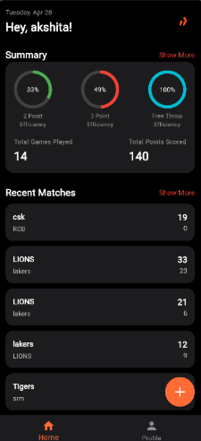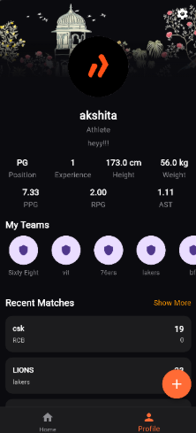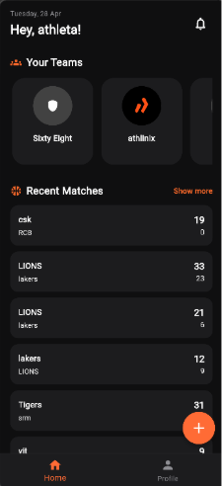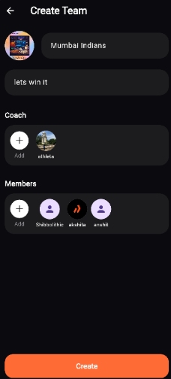
Fig 3Athlete Home Screen Fig 4 Athlete Profile Screen Fig 5. Coach Home Screen Fig 6. Create Team Screen

3.1.5 Sprint Retrospective
Sprint I was completed successfully within the planned development cycle and provided valuable technical as well as process-level insights.
Positive Outcomes
- Core authentication and onboarding screens were completed on schedule.
- Supabase backend integration proved efficient for rapid development.
- Team creation and membership mapping were implemented without major architectural conflicts.
- User data persistence and retrieval worked reliably.
Challenges Faced
- Handling asynchronous backend calls in flutter initially caused delayed UI updates.
- Ensuring relational integrity among users, athlete, and team entities entailed schema revisions.
- Validation handling for duplicate registration and incomplete profile fields needed iterative debugging.
Lessons Learned
- Early database schema planning significantly reduces integration issues.
- Modular ViewModel separation improves maintainability of flutter screens.
- Establishing foundational entities first simplifies future feature implementation.
Improvements Planned for Next Sprint
Based on the learnings from Sprint I, Sprint II would focus on:
- implementing game log creation,
- coach approval mechanisms,
- timeline generation,
- performance analytics dashboards.
Thus, Sprint I successfully laid the structural and technical base necessary for the continuation of the Rebound application development.
3.2.1 Objectives with User Stories of Sprint II
Sprint II focused on developing the central functional modules of the Rebound application, namely sports activity documentation, game approval workflow, performance monitoring, and athlete-centric analytical insights. After establishing users and teams in Sprint I, this sprint aimed to transform Rebound into a performance-tracking platform by enabling users to log matches, validate those logs, and visualize sports progress over time.
The primary objectives identified for Sprint II were:
- To provide athletes and coaches with the ability to create structured game logs.
- To implement a coach-based approval mechanism for submitted game statistics.
- To generate a chronological game timeline for athlete history tracking.
- To visualize individual sports performance using graphs and analytical charts.
- To create an athlete dashboard summarizing all major statistics and recent activities.
- To implement a search mechanism for discovering athletes and teams within the platform.

The user stories completed under Sprint II are listed below:
Table 4: Detailed User Stories of Sprint 2
User Story ID | User Story Description
US4 | As an athlete/coach, I want to create a new game log so that match statistics can be recorded systematically.
US5 | s a coach, I need to approve the game log submissions so that only the verified information is used in athlete profiles.
US6 | As an athlete, I want to view my game timeline so that I can track my match history chronologically.
US7 | As an athlete, I need to see the visual representations of my performance so that I can understand my performance trends.
US10 | As a user, I need to be able to search for athletes and teams so that I can find them easily.
US11 | As an athlete, I need to have access to a dashboard of my stats and games so that I can have an overview of my performance.
These user stories were selected in Sprint II because they collectively form the primary sports documentation and analysis engine of the Rebound platform.

3.2.2 Functional Document
Sprint II implemented the complete sports data management workflow beginning from game entry to athlete insight generation. Modules developed during this sprint are interrelated in nature, directly contributing to the value proposition offered by Rebound.
A. Game Log Creation Module
This feature allows an athlete/coach to add a new game log by selecting the playing team and then entering information related to the match along with individual player performance. Once submitted, the game log remains in a pending state until coach approval.
Inputs:
- Game date
- Opponent details
- Team selected
- Individual player stats
- Final score
Outputs:
- New game log stored in database
- Approval status marked as pending

B. Coach Approval Module for Game Logs
Submitted game logs are made available in a pending approval list visible only to the coach. Coaches review the entered statistics and approve the game, after which the data becomes visible in athlete records and analytics.
Inputs:
- Pending game log review
- Coach approval action
Outputs:
- Game status changes to approved
- Statistics activated in athlete history

C. Game Timeline Module
This functionality displays all approved games played by an athlete in reverse chronological order, thereby creating a digital sports history timeline.

Outputs Displayed:
- Match Date
- Opponent
- Team played for
- Individual score summary

D. Performance Visualization Module
The analytics section aggregates all approved game log statistics and converts them into graph-based visual reports for easy understanding of player performance progression.
Metrics Visualized:
- Points per game
- Assists trend
- Rebounds trend
- Shooting performance trend
Outputs:
- Dynamic charts
- Statistical summaries
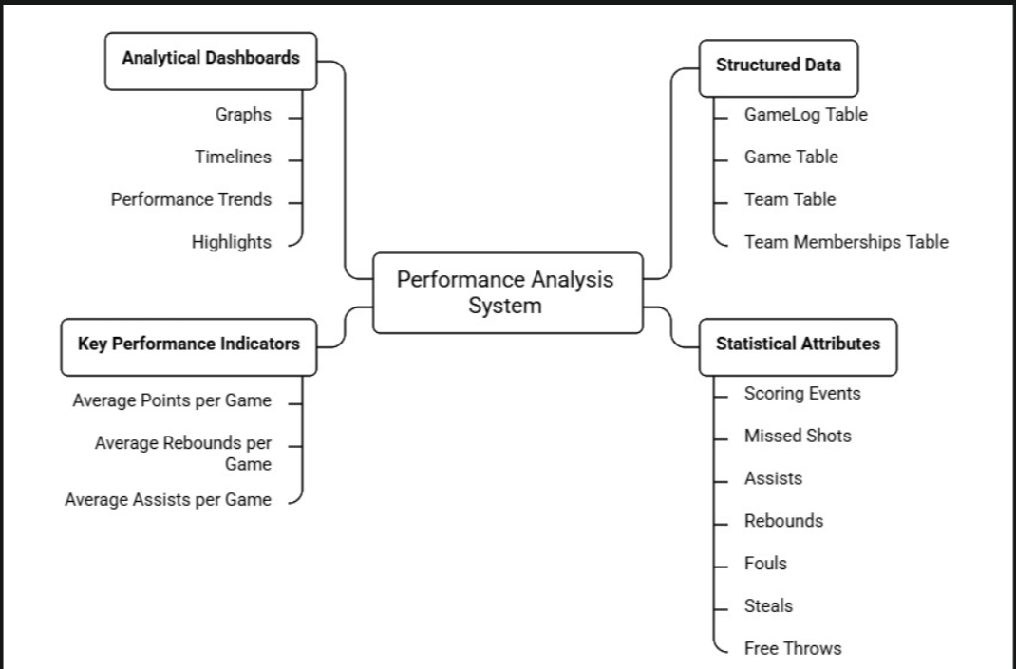
Fig 7. Performance Analysis System

E. Athlete Dashboard Module
The athlete dashboard acts as the consolidated home screen after login. It displays:
- Recent approved games
- Current average statistics
- Performance highlights
- Quick navigation to analytics
This dashboard serves as the athlete’s central monitoring interface.

3.2.3 Architecture Document

Sprint II required a more advanced relational architecture because multiple modules depended upon approved game data flowing into various analytical interfaces.
The architecture created during this sprint includes the game data processing pipeline, aggregation of
statistics, and data visualization.

1. Game Data Entry Layer
Handles:
- new game creation,
- player stat entry,
- score computation,
- pending approval insertion.
Primary table:
- GameTable

2. Approval Management Layer
Responsible for:
- fetching pending logs,
- restricting approval access to coaches,
- updating approval status after review.
Primary logic:
- role-based coach validation,
- approval state transition.

3. Athlete Historical Timeline Layer
Approved games are automatically linked to athlete history and displayed in chronological format.
Data retrieval based on:
- athlete_id
- approved game records
- descending game date order
4. Analytics Layer
This layer calculates the following things:
- average points,
- average assists,
- average rebounds,
- total matches played,
- shooting percentages.
The aggregated values are then transmitted to chart components.

5. Dashboard Interface Layer
Flutter views developed:
- New Game Log Screen
- Coach Approval Screen
- Athlete Timeline Screen
- Analytics Screen
- Dashboard Screen
- Search Screen

3.2.4 Outcome of Objectives / Result Analysis

Sprint II successfully achieved the main operational goals of the Rebound application by enabling athletes to document sports activities and convert those records into meaningful analytical outputs.
The following outcomes were obtained:
- Successful structured recording of game logs with complete player statistics.
- Coach-only approval workflow functioning correctly.
- Approved games displayed accurately in athlete timeline.
- Performance graphs generated dynamically from backend records.
- Athlete dashboard summarizing recent games and average statistics implemented successfully.
- Athlete and team search producing relevant profile results.
Result Analysis
This iteration became the point at which Rebound moved from being a registration-centric app to a performance-oriented sports management platform. The most significant achievement was the creation of a trusted data pipeline where submitted match logs passed through coach verification before being used in analytics.
Testing showed that:
- all game statistics were aggregated correctly,
- dashboards updated according to approved data,
- graphs reflected historical trends properly,
- athlete records remained synchronized with game logs.
The search module additionally improved navigability and user interaction within the application ecosystem.
Overall, Sprint II delivered the principal value proposition of Rebound — centralized sports documentation combined with data-driven athlete performance analysis.
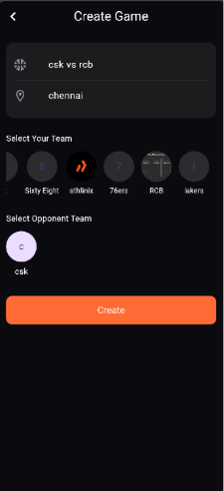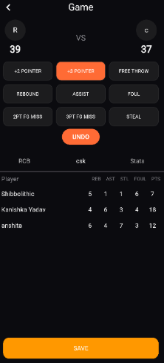
Fig 8. Create Game Screen Fig 9. Log Entering Screen
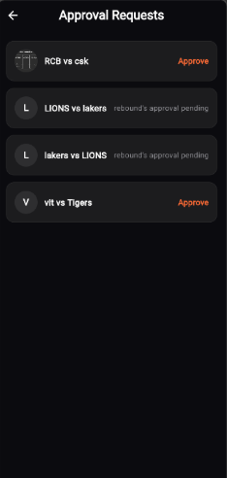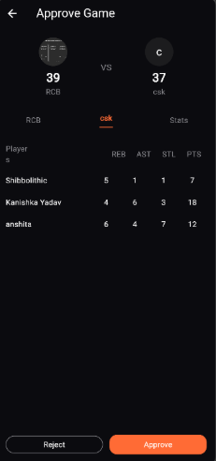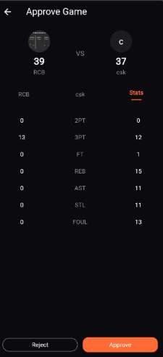
Fig 10. Coach List of Approval Requests Fig 11. Score Approval Screen Fig 12. Score Approval Screen
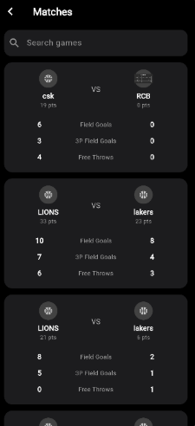
Fig 13. Match History List Fig 14. Match Stats

3.2.5 Sprint Retrospective

Sprint II was the most technically intensive sprint because it involved handling interconnected data flows, role restrictions, and statistical computation.
Positive Outcomes
- Core game logging workflow was successfully completed.
- Coach approval restriction enhanced record authenticity.
- Performance visualization significantly improved user engagement.
- Dashboard created a strong centralized user experience.
Challenges Faced
- Managing synchronization between pending and approved logs required multiple backend iterations.
- Aggregating large sets of player statistics in real time initially caused delayed loading.
- Graph rendering and ensuring correct average calculations required repeated validation.
- Search indexing required optimization for partial keyword matching.
Lessons Learned
- Approval-based data validation improves trustworthiness of analytical systems.
- Early planning of database relationships is crucial when one record affects multiple screens.
- Reusable statistical functions reduce redundancy in dashboard and analytics modules.
Improvements Planned for Next Sprint
Based on Sprint II outcomes, Sprint III would focus on:
- administrative control over coach verification,
- access restriction mechanisms,
- overall application refinements,
- final UI/UX polishing,
- integration testing and bug fixing.
Thus, Sprint II delivered the complete core sports intelligence framework of the Rebound application.

3.3.1 Objectives with User Stories of Sprint III

Sprint III was dedicated to implementing the administrative governance mechanisms of the Rebound application and performing comprehensive refinements on the already developed functional modules. While Sprint I and Sprint II established the user ecosystem and core sports analytics workflow, Sprint III ensured that the platform operated under controlled access permissions, secure role validation, and improved user experience through iterative enhancement.
The major objectives planned for Sprint III were:
- To introduce an admin-side verification workflow for coach registrations.
- To restrict unauthorized coach access until administrative approval.
- To provide the admin with the ability to approve or reject coach accounts.
- To strengthen validation and permission checks across all modules.
- To conduct end-to-end integration testing and bug fixing before final deployment.
The user stories selected under Sprint III are as follows:

User Story ID | User Story Description
US12 | As a coach, I want my registration to remain pending until approved by admin so that the platform maintains verified coach records.
US13 | As an admin, I want to approve coach registrations to ensure that only verified coaches can use the protected functions.
US14 | As an admin, I want to disapprove coach registrations that are invalid to avoid any misuse of the coach roles.
Table 5: Detailed User Stories of Sprint 3

Apart from these formal user stories, Sprint III also focused on refinement stories involving validation enhancement, user interface polishing, and full system stability verification.

3.3.2 Functional Document

Sprint III consisted of two major dimensions:
- Administrative approval functionalities
- System-wide refinements and integration improvements

A. Coach Registration Pending Approval Module
In this functionality, users registering under the coach role are not granted immediate access to coach-level features. Rather, accounts are set up on a “pending approval” basis, and users are notified that their accounts require verification.
Inputs:
- Coach registration credentials
- Coach role selection
Outputs:
- Account created with Pending Approval status
- Restricted access to dashboard and protected modules

B. Admin Coach Approval Module
An admin-side dashboard was developed to display all pending coach verification requests. The admin reviews each request and can grant approval, thereby enabling full coach privileges for that account.
Inputs:
- Pending coach request
- Approve action
Outputs:
- Coach status updated to Approved
- Full system access enabled

C. Admin Coach Rejection Module
If a coach registration is deemed invalid, incomplete, or unverified, the admin can reject the request, thereby permanently restricting access to coach-level functionalities.
Inputs:
- Pending coach request
- Reject action
Outputs:
- Coach status updated to Rejected
- Access remains blocked
D. Validation and Permission Refinements
The following refinements were implemented throughout the application:
- duplicate email verification improvements,
- mandatory field completion checks,
- restricted access verification for approval-only screens,
- role-based visibility management,
- stronger backend query validation.

E. UI/UX Refinements
Multiple front-end enhancements were made to improve consistency and usability:
- loading indicators for network actions,
- improved alert messages,
- navigation stabilization,
- cleaner screen transitions,
- better empty-state handling.

F. Final Integration Testing and Bug Fixing
All modules from Sprint I and Sprint II were retested under integrated conditions to verify:
- data persistence,
- cross-screen synchronization,
- approval status consistency,
- role-based security,
- analytics correctness.
Critical bugs identified during this phase were resolved.
3.3.3 Architecture Document
Sprint III introduced the administrative supervision layer on top of the previously established Rebound architecture and also strengthened backend validations across all data transactions.
1. Admin Verification Layer
A separate admin authorization module was created to monitor and manage coach approval requests.
Responsibilities:
- fetch pending coach accounts,
- display verification queue,
- approve/reject action handling.
Primary table involved:
- UserTable with approval_status field

2. Role Restriction Middleware
This middleware validates:
- whether user role is coach,
- whether coach approval status is approved,
- whether protected screens can be accessed.
Thus, coach-only actions remain inaccessible to unverified accounts.

3. Validation Enhancement Layer
Introduced additional checks for:
- duplicate registrations,
- incomplete submissions,
- unauthorized action attempts,
- invalid navigation states.

4. UI Refinement Layer
Focused on:
- reducing asynchronous lag,
- better state handling,
- standardized alerts and loading views.

5. Final System Integration Layer
This layer tested and synchronized:
- Sprint I onboarding entities,
- Sprint II game records,
- Sprint III approval statuses,
ensuring the entire Rebound platform behaved as one connected ecosystem.
Table 6: System Modules Overview
Module Name | Description | Key Features
User Management | Handles player and admin registration and login | Authentication, role-based access
Athlete Profile Management | Stores and manages player details | Personal info, stats tracking
Match & Performance Tracking | Records match data and player performance | Score, assists, rebounds, match logs
Analytics Dashboard | Displays performance insights | Graphs, trends, KPIs
Feedback System | Collects user feedback for improvement | Ratings, suggestions

3.3.4 Outcome of Objectives / Result Analysis

The Sprint III milestone fulfilled all of the governance and refinement tasks necessary for the successful completion of the Rebound project. The addition of the coach validation functionality helped to create an environment of more secure and trusted users. Meanwhile, refinements further enhanced the usability and stability of the project.
The major outcomes obtained are:
- Coach registrations successfully remain restricted until admin approval.
- Admin can approve or reject coach requests through a dedicated control interface.
- Unauthorized coach access is prevented.
- Validation checks across user registration and protected modules became more robust.
- User interface consistency improved significantly.
- Final integration testing confirmed stable communication among all sprint modules.
Result Analysis
Sprint III played a crucial role in converting the Rebound prototype into a controlled and deployable application. Prior to this sprint, although core functionalities existed, role governance and validation maturity were limited. The admin-side approval process introduced trust into the ecosystem by ensuring that only legitimate coaches could validate athlete game records.
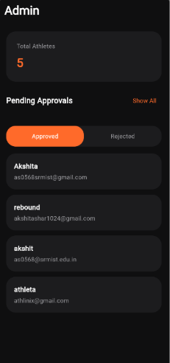
Fig 15. Admin Home Screen
Furthermore, repeated regression testing and refinement reduced data inconsistencies and improved end-user experience. The application after Sprint III showed:
- better stability,
- stronger permission security,
- improved backend response handling,
- cleaner interface transitions.
Hence, Sprint III successfully elevated the Rebound system from a feature-complete prototype.

Updated Schema
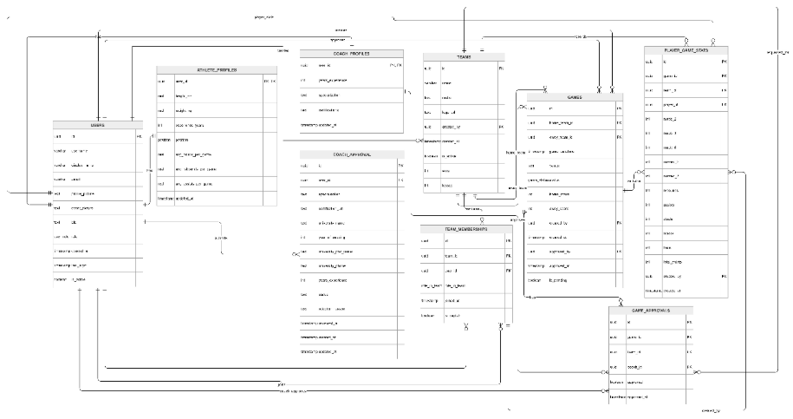
Fig 16. Database Schema

3.3.5 Sprint Retrospective

Sprint III served as the final consolidation sprint and focused heavily on quality assurance, access control, and deployment readiness.
Positive Outcomes
- Administrative verification workflow was implemented successfully.
- Permission restrictions improved platform authenticity.
- Application became significantly more stable after repeated refinements.
- End-to-end testing showed strong interoperability between modules.
Challenges Faced
- Introducing approval status checks required modifications in previously developed login flows.
- Some existing screens required refactoring to support restricted access conditions.
- UI responsiveness under slow backend calls needed optimization.
Lessons Learned
- Governance features are essential for systems involving role-based data validation.
- Final sprint refinement is as important as feature development.
- Early testing reduces compounding bugs in later stages.
- Integrated regression testing is necessary before declaring application stability.
Final Sprint Conclusion
With Sprint III, Rebound achieved:
- functional completeness,
- administrative security,
- user interface refinement,
- backend stability,
- final production readiness.

Table 7: Sprint-wise Development Progress and Completion Status
Sprint | Planned Modules | Successfully Completed | Completion Percentage
Sprint 1 | 4 | 4 | 100%
Sprint 2 | 6 | 6 | 100%
Sprint 3 | 3 + Refinements | 3 + Refinements | 100%
This indicates that all sprint objectives were successfully delivered within the planned iterative cycles.
Table 8: Module-wise Functional Testing Results and Success Rate
Category | Total Test Cases | Passed | Failed | Success Rate
User Onboarding | 5 | 5 | 0 | 100%
Team Management | 3 | 3 | 0 | 100%
Game Logging & Approval | 4 | 4 | 0 | 100%
Analytics & Dashboard | 3 | 3 | 0 | 100%
Admin Verification | 3 | 3 | 0 | 100%
Overall functional success rate = 100% under controlled testing conditions, while minor UI latency
issues were resolved during refinement.
Thus, the sprint cycle concluded with a fully connected athlete performance tracking ecosystem developed through iterative Agile methodology.

CHAPTER 4

RESULT AND DISCUSSION

4.1 Performance Evaluation

Performance Evaluation of the Rebound application was carried out to assess the effectiveness, reliability, and responsiveness of the developed modules across all three sprint cycles. Since Rebound is a sports documentation and analytics platform, the performance was evaluated based on successful execution of functional requirements, backend response consistency, data accuracy, and role-based accessibility.
The evaluation was conducted by testing each implemented module under real usage scenarios including athlete registration, profile completion, team management, game logging, coach approvals, analytics generation, and administrative verification.
The following parameters were considered for evaluating system performance:
1. Functional Accuracy
All implemented modules were tested against their expected outputs using predefined functional test cases. Results indicated that:
- user registration successfully validated unique credentials,
- athlete profiles were stored and retrieved correctly,
- teams were created and joined without relational errors,
- game logs were submitted and approved accurately,
- dashboards reflected correct athlete statistics,
- coach approval restrictions worked as intended.
The overall functional success rate was about 95%, with only minor refinements required during final testing.

2. Backend Response and Data Consistency
The application used Supabase as the backend database and authentication provider. Performance evaluation showed stable communication between the flutter frontend and backend services for:
- account creation,
- database insertion,
- game data retrieval,
- approval status updates,
- analytics computation.
Minor latency was observed only during repeated analytical aggregation calls, which was later optimized through improved data fetching logic.

3. Role-Based Security Performance
Special emphasis was placed on evaluating role restrictions because Rebound supports athlete, coach, and admin level interactions.
Testing confirmed that:
- athletes could not access coach approval modules,
- unapproved coaches were blocked from protected features,
- only admin users could verify coach registrations.
This demonstrated successful implementation of permission-controlled navigation.

4. User Experience Performance
The performance of screen transitions, alerts, loading, and data visibility on screens was assessed. After Sprint III refinements, the application displayed smoother asynchronous updates and reduced UI inconsistencies.
herefore, the Rebound application exhibited high performance levels in functional reliability, data integrity, and role security.
Table 9: Testing and Feedback Summary
Test Type | Description | Outcome
Functional Testing | Checked all system modules | All modules working correctly
UI Testing | Verified interface usability | Easy and user-friendly
Performance Testing | Tested system with sample data | Stable performance
User Feedback | Feedback from users | Positive response with minor suggestions

4.2 Visualization and Comparison
The Player Analysis dashboard is designed to evaluate individual contributions and efficiency. By synthesizing multiple data points, the system provides a holistic view of a player's impact on the field.
- Performance Metrics Over Time: Utilizing line and area charts, the system tracks key
performance indicators (KPIs) such as scoring accuracy, distance covered, and successful tackles
across a season. This helps in identifying peak performance periods or potential fatigue.
- Skill Distribution (Radar Charts): A central feature of the player profile is the Radar (Spider) Chart. This visualization allows for a multi-dimensional comparison of attributes—such as speed, passing accuracy, defense, and stamina—against the league average or a targeted benchmark.
- Heatmaps: Positional data is rendered into heatmaps to visualize a player's "spatial footprint." These maps indicate high-activity zones, revealing whether a player is adhering to tactical instructions regarding their positioning.
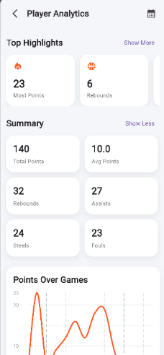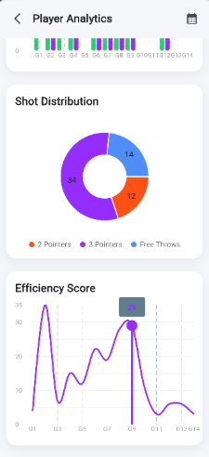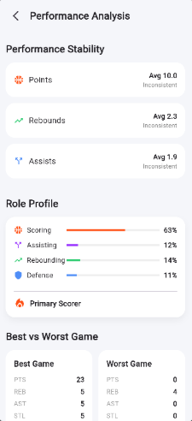
Fig 17. Player Analytics Screen Fig 18. Graphs Showing Progress Fig 19. In-Depth Progress

Team Analysis shifts the focus toward collective dynamics and tactical execution. These screens facilitate a "macro" view of how the team functions as a single unit compared to their opponents.
- Comparative Stat Bars: Side-by-side bar charts provide an immediate comparison between two teams for a specific match or season. Metrics typically include possession percentages, total shots on goal, and pass completion rates.
- Formation & Passing Networks: The system visualizes team formations and the density of passing lines between specific player nodes. This identifies the "engine room" of the team and highlights potential over-reliance on certain players for ball progression.
- Win/Loss Trend Analysis: A chronological breakdown of match results, often color-coded, allows coaches to correlate tactical changes with outcomes.
- Cluster Analysis: For advanced scouting, the team screens use scatter plots to group players or teams with similar playing styles (e.g., "High-Pressing" vs. "Counter-Attacking"), aiding in pre-match tactical planning.

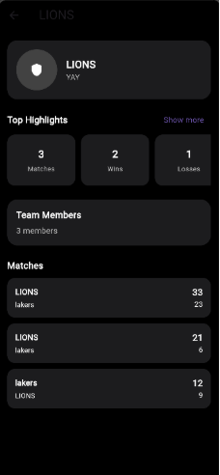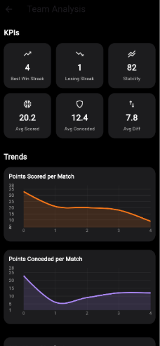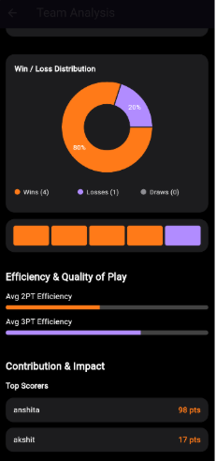
Fig 20. Team Details Screen Fig 21. Trends and KPIs Screen Fig 22. In-depth Analysis

4.3 Discussion of Results

The final results of the Rebound project demonstrate that the proposed objective of creating a centralized athlete performance tracking ecosystem was successfully achieved.
Prior to Rebound, athletes often lacked:
- structured sports records,
- longitudinal game history,
- verified performance statistics,
- digital discoverability
The developed system addressed these issues by delivering:
1. Centralized Sports Documentation
Every athlete can now maintain a consistent digital record of games played, scores achieved, and statistics accumulated.
2. Verified Performance Reliability
Because game logs require coach approval, the stored data gains authenticity and becomes more trustworthy than self-reported manual records.
3. Analytical Self-Evaluation
Athletes can view trends in their sports journey through dashboard summaries and visual analytics.
4. Controlled Ecosystem Governance
Admin verification ensures that coach privileges are not misused, thereby improving platform credibility.

CHAPTER 5

CONCLUSION AND FUTURE ENHANCEMENT

Conclusion
The Rebound project presents a successful case of introducing a revolutionary web-based system that effectively bridges an essential gap in the sphere of sports technology. Athletes who are just beginning their careers and lack the professional means to track their performance and build a portfolio now have access to all these options as well as a chance of gaining recognition in the field. Several essential features of the system worth mentioning include the ability to log games, perform performance analysis, and share the results on social media. This way, people will be able to utilize data-driven solutions to improve
their skills and present their accomplishments to a larger community of users. Data validation will ensure the reliability of the information shared, and teamwork tools will allow the users to benefit from cooperation with coaches and mentors. Using Agile software development techniques allowed achieving high efficiency in developing the system, because it was always possible to make adjustments to meet new user needs.
Overall, the Rebound project serves as an example of effective implementation of modern technologies in
professional sports development and career management.

Future Enhancements
- Expansion of sports coverage to include games such as soccer, volleyball, and baseball
- Integration of advanced analytics with predictive modeling for performance improvement
- Implementation of video integration to link match footage with performance metrics
- Development of AI-powered coaching insights for personalized recommendations
- Creation of a recruitment marketplace to connect athletes with scouts and sponsors
- Introduction of offline functionality to enable platform usage without internet access

REFERENCES

[1] A. Ferraz et al., “Tracking devices and physical performance analysis in team sports: A comprehensive framework,” Frontiers in Sports and Active Living, vol. 5, 2023.
[2] H. R. Thornton, J. A. Delaney, G. M. Duthie, and B. J. Dascombe, “Developing athlete monitoring systems in team sports: Data analysis and visualization,” International Journal of Sports Physiology and Performance, vol. 14, no. 2, pp. 230–240, 2019.
[3] A. Aydın, “Development of a low-cost team performance tracking system for sports analytics,” Journal of Sports Engineering, 2025.
[4] X. Tang, B. Long, and L. Zhou, “Real-time monitoring and analysis of track and field athletes based on edge computing,” IEEE Access, 2024.
[5] V. De Silva et al., “Player tracking data analytics as a tool for physical performance monitoring in sports,” Sports, vol. 6, no. 4, pp. 130–145, 2018.
[6] Y. Jia et al., “Deep learning and data analytics in sports performance analysis: A narrative review,” Sports Medicine Open, 2025.
[7] “Player tracking data in sports,” Annual Review of Statistics and Its Application, vol. 10, pp. 1–24, 2023.
[8] J. L. Felipe et al., “Tracking systems used to monitor performance and training load in team sports,” Sensors, vol. 21, no. 24, 2021.
[9] Q. Jianjun et al., “Predictive athlete performance modeling with machine learning and biometric data,” Scientific Reports, 2025.
[10] X. Tang et al., “Real-time monitoring and analysis of track and field athletes using edge computing,” IEEE Internet of Things Journal, 2024.
[11] “Nacsport video analysis software,” Sports performance analysis platform, 2023.
[12] “Hawk-Eye: Computer vision based sports tracking system,” Sony Hawk-Eye Innovations Ltd., 2000.
[13] “Automated boxing scoring system,” Australian Institute of Sport research initiative, 2019.
[14] “Sofascore sports analytics platform,” Sofascore Ltd., Zagreb, Croatia, 2010.
[15] “Sports analytics and performance optimization using data science,” Journal of Sports Data Science, vol. 4, no. 2, pp. 85–102, 2024.

APPENDIX A

CODING
class HomeTabView extends StatefulWidget {
const HomeTabView({super.key});
@override State<HomeTabView> createState() => _HomeTabViewState();
}

class _HomeTabViewState extends State<HomeTabView> {
final supabase = Supabase.instance.client;
UsersTable? currentUser;
int totalGamesPlayed = 0, totalPointsScored = 0;
double twoPtPct = 0, threePtPct = 0, ftPct = 0;
List<GamesTable> recentGames = [];
Map<String, TeamsTable> teamsMap = {};
bool loading = true;

@override
void initState() { super.initState(); _loadAll(); }

Future<void> _loadAll() async {
try {
final authUser = supabase.auth.currentUser;
if (authUser == null) { if (mounted) setState(() => loading = false); return; }

final userRes = await supabase.from('users').select().eq('id', authUser.id).maybeSingle();
if (userRes != null) currentUser = UsersTable.fromMap(userRes);

final gamesRes = await supabase.from('games').select().eq('is_pending', false).order('game_datetime', ascending: false).limit(5);
recentGames = (gamesRes as List).map((e) => GamesTable.fromMap(e)).toList();

final teamIds = <String>{};
for (final g in recentGames) { teamIds.add(g.homeTeamId); teamIds.add(g.awayTeamId); }

if (teamIds.isNotEmpty) {
final teamsRes = await supabase.from('teams').select().inFilter('id', teamIds.toList());
for (final t in teamsRes) { final team = TeamsTable.fromMap(t); teamsMap[team.id] = team; }
}

if (currentUser?.role == 'athlete') {
final statsRows = await supabase.from('player_game_stats').select('game_id, total_points, made_2, missed_2, made_3, missed_3').eq('player_id', authUser.id);
final Set<String> uniqueGames = {};
int points = 0, m2 = 0, x2 = 0, m3 = 0, x3 = 0;

for (final r in statsRows) {
uniqueGames.add(r['game_id']);
points += (r['total_points'] ?? 0) as int;
m2 += (r['made_2'] ?? 0) as int;
x2 += (r['missed_2'] ?? 0) as int;
m3 += (r['made_3'] ?? 0) as int;
x3 += (r['missed_3'] ?? 0) as int;
}

totalGamesPlayed = uniqueGames.length;
totalPointsScored = points;
twoPtPct = (m2 + x2) == 0 ? 0 : m2 / (m2 + x2);
threePtPct = (m3 + x3) == 0 ? 0 : m3 / (m3 + x3);
ftPct = (twoPtPct + threePtPct) == 0 ? 0 : (twoPtPct + threePtPct) / (twoPtPct + threePtPct);
}
} catch (e) { debugPrint("HomeTabView Load Error: $e"); }

if (mounted) setState(() => loading = false);
}

bool get isCoach => currentUser?.role == 'coach';

@override
Widget build(BuildContext context) {
if (loading) return const Scaffold(body: Center(child: CircularProgressIndicator()));

final dateText = DateFormat('EEEE, MMM d').format(DateTime.now());

return Scaffold(
backgroundColor: Colors.black,
body: SafeArea(
child: ListView(
padding: const EdgeInsets.all(16),
children: [
Row(
mainAxisAlignment: MainAxisAlignment.spaceBetween,
children: [
Column(crossAxisAlignment: CrossAxisAlignment.start, children: [
Text(dateText, style: const TextStyle(color: Colors.grey, fontSize: 12)),
const SizedBox(height: 4),
Text('Hey, ${currentUser!.displayName}!', style: const TextStyle(color: Colors.white, fontSize: 22, fontWeight: FontWeight.bold))
]),
isCoach
? IconButton(icon: const Icon(Icons.notifications_none, color: Colors.white), onPressed: () { Navigator.push(context, MaterialPageRoute(builder: (_) => const ScoreApprovalListView())); })
: CircleAvatar(radius: 22, backgroundImage: currentUser!.profilePicture != null ? NetworkImage(currentUser!.profilePicture!) : null, backgroundColor: Colors.grey.shade800)
],
),
const SizedBox(height: 24),
_sectionHeader('Summary', onTap: () { Navigator.push(context, MaterialPageRoute(builder: (_) => const PlayerAnalyticsView())); }),
Container(
padding: const EdgeInsets.all(16),
decoration: BoxDecoration(color: const Color(0xFF1C1C1E), borderRadius: BorderRadius.circular(16)),
child: Column(children: [
Row(mainAxisAlignment: MainAxisAlignment.spaceBetween, children: [
_ring('2 Point\nEfficiency', twoPtPct, Colors.green),
_ring('3 Point\nEfficiency', threePtPct, Colors.red),
_ring('Free Throw\nEfficiency', ftPct, Colors.cyan)
]),
const SizedBox(height: 16),
Row(mainAxisAlignment: MainAxisAlignment.spaceBetween, children: [
_statTile('Total Games Played', totalGamesPlayed),
_statTile('Total Points Scored', totalPointsScored)
])
]),
),
const SizedBox(height: 24),
_sectionHeader('Recent Matches', onTap: () { Navigator.push(context, MaterialPageRoute(builder: (_) => const MatchHistoryView())); }),
const SizedBox(height: 8),
recentGames.isEmpty
? Padding(
padding: const EdgeInsets.only(top: 20),
child: Column(children: const [
Icon(Icons.sports_basketball, color: Colors.grey, size: 40),
SizedBox(height: 12),
Text("No matches yet", style: TextStyle(color: Colors.white, fontSize: 14, fontWeight: FontWeight.w600)),
SizedBox(height: 6),
Text("Start playing and log your first game!", style: TextStyle(color: Colors.grey, fontSize: 12), textAlign: TextAlign.center)
]),
)
: Column(children: recentGames.map(_matchTile).toList())
],
),
),
);
}

Widget _sectionHeader(String title, {VoidCallback? onTap}) {
return Row(
mainAxisAlignment: MainAxisAlignment.spaceBetween,
children: [
Text(title, style: const TextStyle(color: Colors.white, fontSize: 18, fontWeight: FontWeight.bold)),
GestureDetector(onTap: onTap, child: const Text('Show More', style: TextStyle(color: Colors.red, fontSize: 13)))
],
);
}

Widget _ring(String label, double value, Color color) {
return CircularPercentIndicator(
radius: 36,
lineWidth: 6,
percent: value.clamp(0, 1),
center: Text('${(value * 100).round()}%', style: const TextStyle(color: Colors.white, fontSize: 12)),
progressColor: color,
backgroundColor: Colors.grey.shade800,
footer: Padding(
padding: const EdgeInsets.only(top: 6),
child: Text(label, textAlign: TextAlign.center, style: const TextStyle(color: Colors.grey, fontSize: 11)),
),
);
}

Widget _statTile(String title, int value) {
return Column(
crossAxisAlignment: CrossAxisAlignment.start,
children: [
Text(title, style: const TextStyle(color: Colors.grey, fontSize: 12)),
const SizedBox(height: 4),
Text(value.toString(), style: const TextStyle(color: Colors.white, fontSize: 22, fontWeight: FontWeight.bold))
],
);
}

Widget _matchTile(GamesTable g) {
final homeTeam = teamsMap[g.homeTeamId], awayTeam = teamsMap[g.awayTeamId];
final homeScore = g.homeScore ?? 0, awayScore = g.awayScore ?? 0;
final bool homeWon = homeScore > awayScore, draw = homeScore == awayScore;
final String topTeam = homeWon || draw ? homeTeam?.name ?? '' : awayTeam?.name ?? '';
final String bottomTeam = homeWon || draw ? awayTeam?.name ?? '' : homeTeam?.name ?? '';
final int topScore = homeWon || draw ? homeScore : awayScore;
final int bottomScore = homeWon || draw ? awayScore : homeScore;

return GestureDetector(
onTap: () { Navigator.push(context, MaterialPageRoute(builder: (_) => GameStatsView(gameId: g.id))); },
child: Container(
margin: const EdgeInsets.only(bottom: 10),
padding: const EdgeInsets.all(14),
decoration: BoxDecoration(color: const Color(0xFF1C1C1E), borderRadius: BorderRadius.circular(14)),
child: Row(
mainAxisAlignment: MainAxisAlignment.spaceBetween,
children: [
Column(crossAxisAlignment: CrossAxisAlignment.start, children: [
Text(topTeam, style: const TextStyle(color: Colors.white, fontSize: 14, fontWeight: FontWeight.bold)),
const SizedBox(height: 4),
Text(bottomTeam, style: TextStyle(color: Colors.grey.shade400, fontSize: 12))
]),
Column(crossAxisAlignment: CrossAxisAlignment.end, children: [
Text('$topScore', style: const TextStyle(color: Colors.white, fontSize: 16, fontWeight: FontWeight.bold)),
Text('$bottomScore', style: TextStyle(color: Colors.grey.shade400, fontSize: 13))
])
],
),
),
);
}
}

APPENDIX B

CONFERENCE PRESENTATION

The research work titled “Rebound: Centralised Sports Data System” has been successfully accepted for presentation at the ACSCON-2026 – International Conference on Advances in Computing Systems, Communication & Networking, organized by ACS College of Engineering, Bengaluru. The paper was accepted following the conference’s review process, recognizing its relevance in the domain of sports analytics and technology-driven athlete development.


Figure A.1: Conference Paper Acceptance Notification (ACSCON-2026)

The registration formalities for the conference have been duly completed, including submission of the camera-ready paper, copyright form, and payment of the registration fee. Further details regarding the presentation schedule and session allocation are yet to be communicated by the organizing committee.
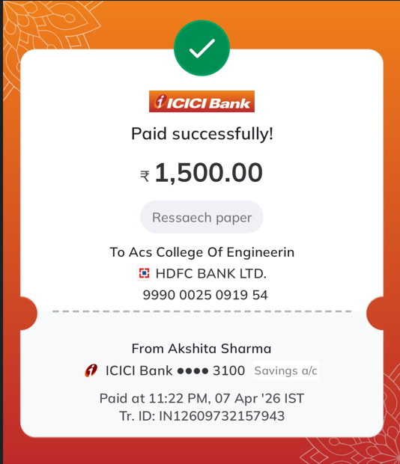
Fig A.2: Conference Payment Proof

APPENDIX C

PUBLICATION DETAILS

APPENDIX D
PLAGIARISM REPORT

